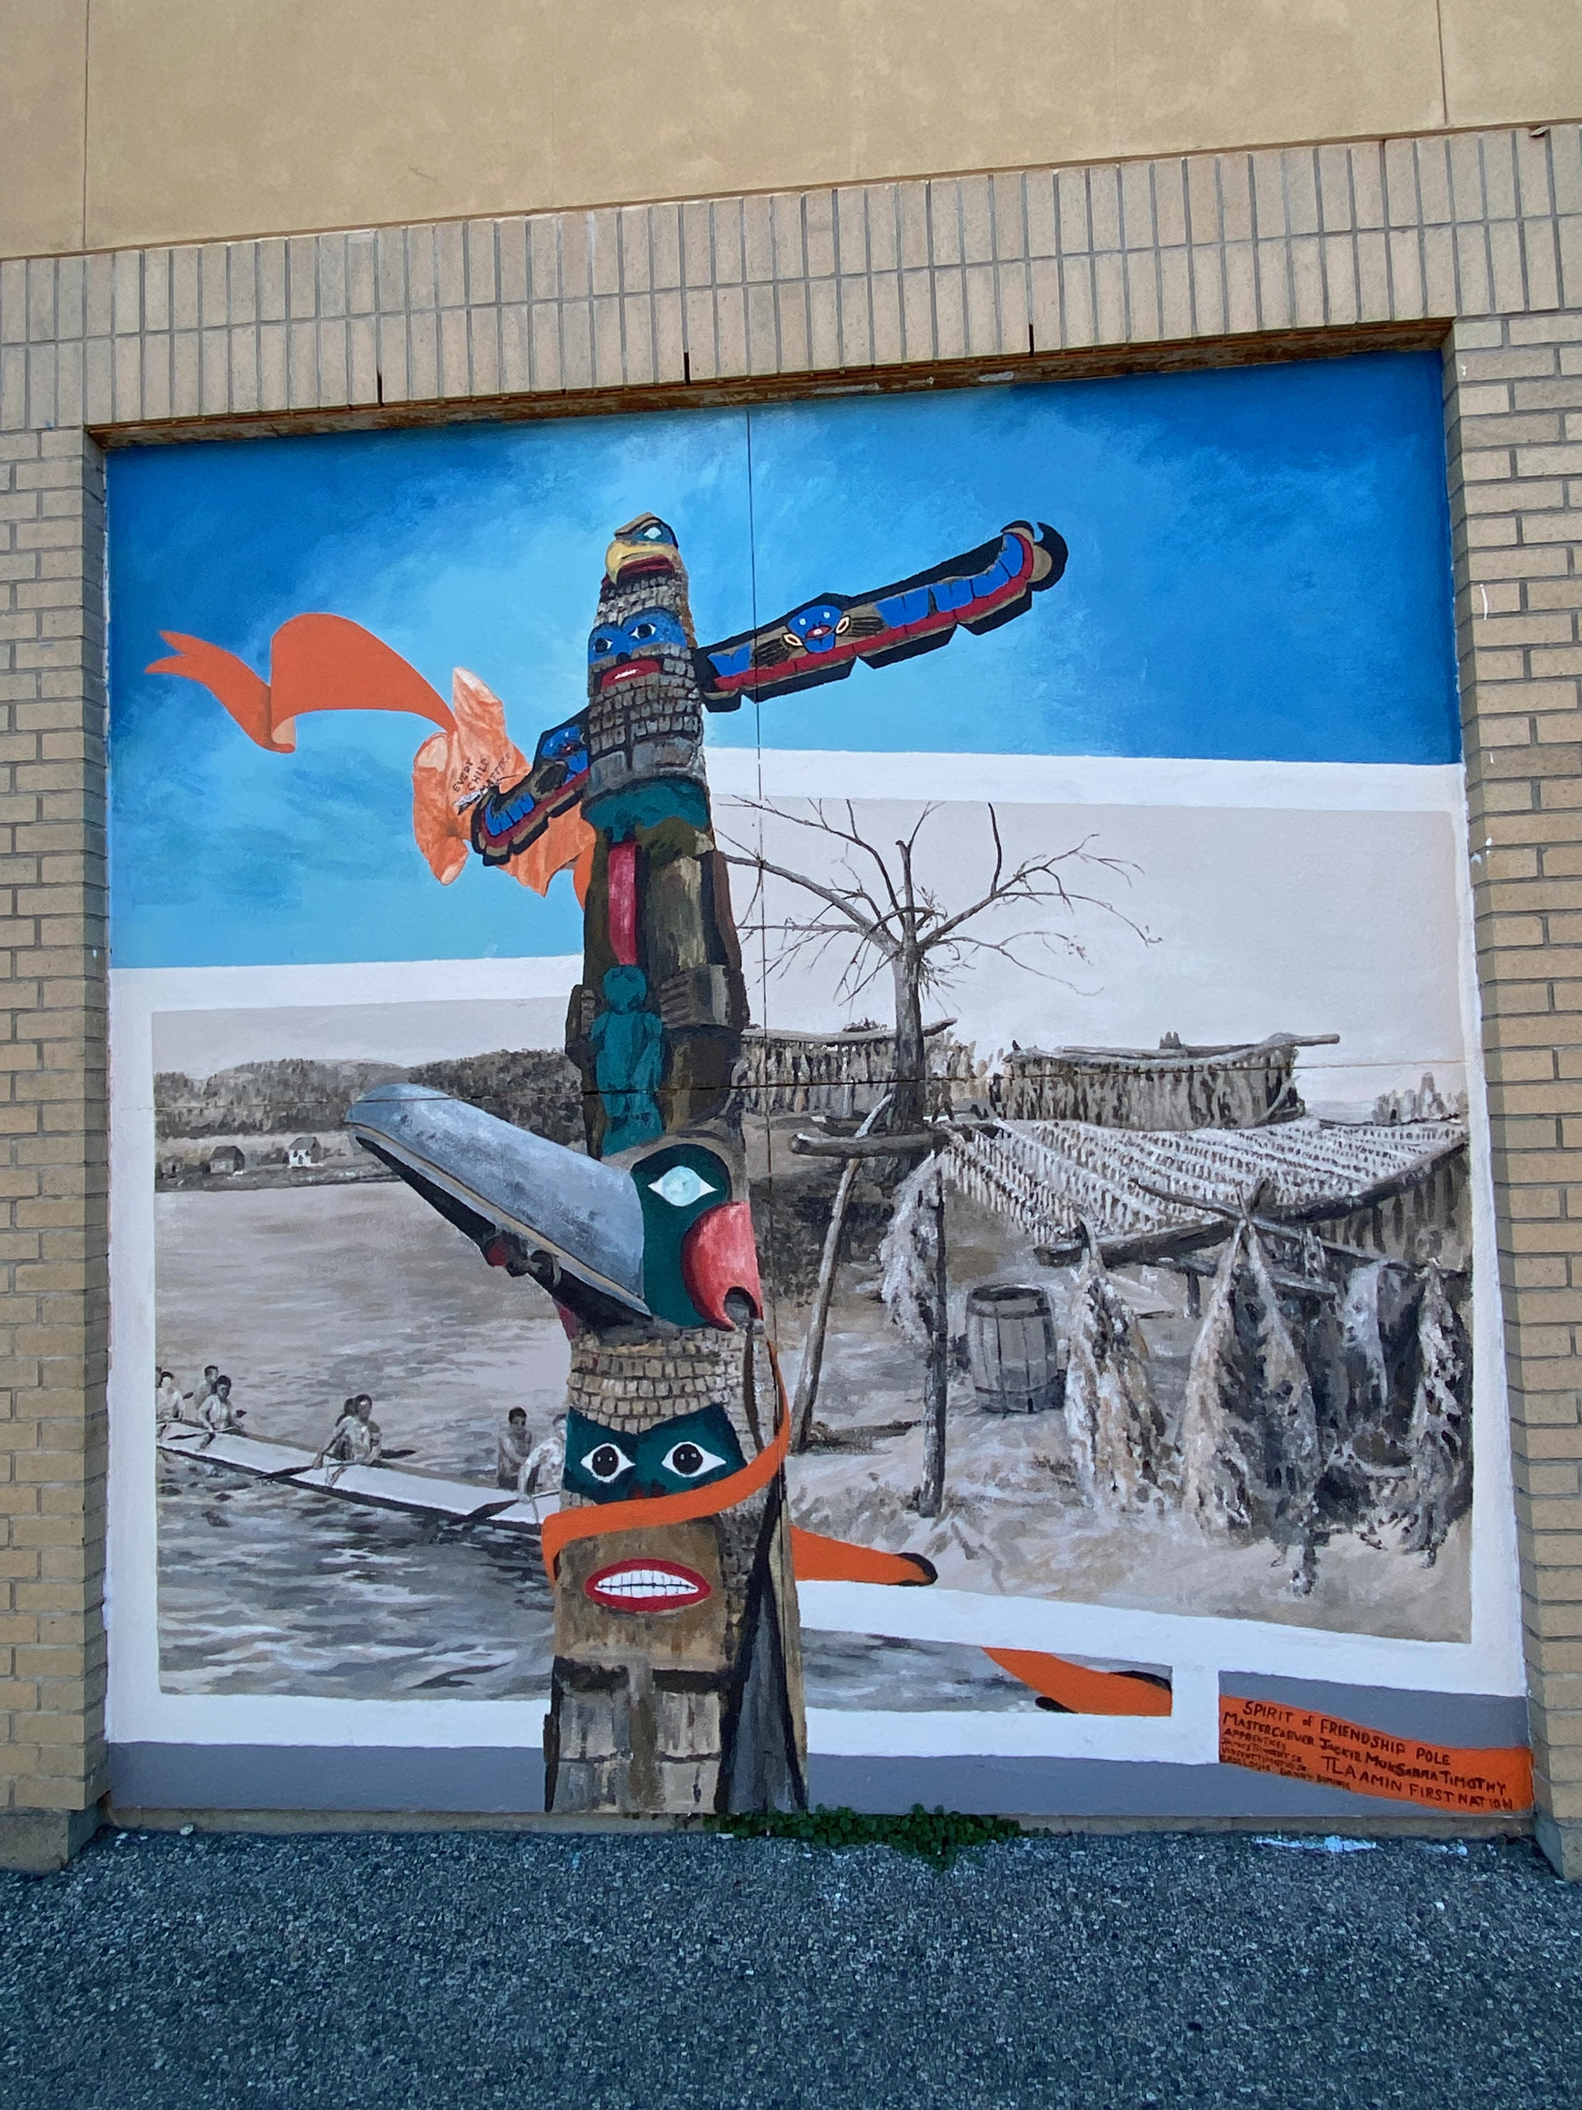

Powell River Brain INjury Society
  - Annual report 2023-2024

Board of Directors

Penny Mebs, Lifetime Member, Honorary Chair
Roger Whittaker – President
Doug Logan – President (Retired)
Dan Dyble – Treasurer
Catherine Peterson - Secretary
Maggie Hathaway - Director
Hugh Prichard - Director
Debbie Hodges -Director
Willemijn Poelen- Director

Staff

Leanne Kerntopf – Executive Director - Effective April 1, 2024
Deborah Dee – Executive Director – Retired March 31, 2024
Rachel Peterson – Office Manager
Jim Wilkins – Peer Support/Outreach Worker
Jeanette Francis – Program Facilitator

Volunteers

Carol Engram – Garden
Jen Nachlas – Art

The Powell River Brain Injury Society is a federally registered not for profit charity providing support, services, education, and awareness relating to acquired brain injury. We acknowledge the financial supports of Vancouver Coastal Health, the Province of British Columbia, the Government of Canada, Community Gaming Branch, Brain Injury Alliance, ICBC, Walmart, and the City of Powell River.

Team Members 1
Table of Contents 2
Message from the Executive Director 3
Message from the President 4
Message from the Treasurer 5
The Year in Review 6
Our Services 7-8
Special Projects and Initiatives 9
Statistics 10
Measures 11
Conclusion 12

The Powell River Brain Injury Society has experienced a year marked by significant changes. After 21 years with Debbie Dee at the helm, she retired March 31, 2024. Debbie led the Society and built us to where we are today, her dedication, passion and unwavering commitment to the Society will not be forgotten. I feel blessed to have had the opportunity to work alongside Debbie for the last four years. The work we have done together has laid the foundation for many more years ahead. Following Debbie's retirement, and the thorough preparations undertaken to ensure the organization's ongoing success, I am honored to have assumed the role of Executive Director.

Our client base continues to grow, and our team of devoted staff members consistently demonstrate their unwavering commitment to aiding everyone who seeks our help. Strengthening relationships within our community and other agencies has played a key role in increasing our numbers. Working with these agencies to identify the needs of clients, and adequately address those core needs has proven to be efficient and beneficial.

Our funders and local supports play a vital role in sustaining our operations, and I extend heartfelt thanks to Vancouver Coastal Health, the Province of British Columbia, the Government of Canada, Community Gaming Branch, Brain Injury Alliance, ICBC, Walmart, and the City of Powell River for their indispensable contributions – without them, none of our achievements would be possible.

Respectfully,

Leanne Kerntopf
Executive Director

Tasks detailed in this report were not completed by me – indeed—as president I simply watched other board members and staff complete tasks according to their competencies as individuals who took the weight of the work onto their own selves. I merely presided over the meetings that allowed for open frank discussions where ideas were discussed and resolutions etc. voted on by the board.

As president I have been available to board members and staff to help clarify some aspects of operations. Including re-emphasizing that as the Powell River Brian Injury Society we are a single purpose organization as detailed in our Constitution. -

Over the last year as president I have overseen the transition of Executive Director to a new ED in Leanne Kerntopf – this has involved engaging a law firm to write up a proper employment contract which will govern over ED expectations as employee and board expectations of staff and the Society which is the employer.
Further to this as a board, we encouraged our treasure to keep open communications with the accountant’s office to ensure financials were ready for this AGM and the proof is in the pudding – we have financial reports completed in time for this AGM. Happy! Happy !
The new ED Leanne, continues to maintain relationships with our historical funders and has recently sought new streams of funding through new relationships.
The Board has worked on a revamp of our governing statutes and procedures to allow us to work together as a Board and serve clients better.
Going forward as president I will be regularly getting together with the ED and make myself available as required to listen to concerns and cheer advances made by staff and the society overall.
It is my hope that we will continue to properly serve those for whom TBI has become a regular part of their lexicon.

Roger Whittaker
President of Powell River Brain Injury Society

This has been a year of transition. I enjoyed working closely with Debbie, our past Executive Director, and now with Leanne and her team to ensure a balanced budget and a plan for expanded funding for the coming year. With Debbie leaving and Leanne taking over, our financial report is wonderfully stable. While funding has decreased, so have our expenses, leaving our Society in a solid financial position. We look forward to the coming year with new financial rigor and fresh funding plans.

I would like to take this opportunity to thank our funders and local support: Vancouver Coastal Health, Community Gaming, Brain Injury Alliance, ICBC, Walmart, the City of Powell River, and the Federal and Provincial Governments. These funds enable high quality service and support the for our client base.

I would also like to thank many others for their generous donations of time and dollars. Your support directly improves life for people living with acquired brain injury. This Society is so important in our community, and I appreciate the perseverance and heart everyone supports it with.

Respectfully,

Dan Dyble,
Treasurer, 2023-24

Staffing and Board Member Changes

We welcomed Leanne Kerntopf as the new Executive Director effective April 1, 2024. Leanne has been with us since June 2020 and brings experience and passion in her new role. Her appointment has brought ease to our clients in having a familiar face at the helm.
With Leanne’s appointment, Rachel Peterson has stepped into her new role as Office Manager, effective April 1, 2024. We welcomed Rachel in April of 2022 as our Outreach Worker, and she has done an amazing job. She is well liked by clients and has earned a great deal of respect in the community with her straightforward approach to service provision.
This year Doug Logan, who has been on the Society board for 21 years retired. Doug was a valued and respected member that was instrumental in shaping the Society into what it is today. Thank you for your service, and we wish you the best in your future endeavors.

Around the Office

On September 15, 2023, we attended a ceremony unveiling our mural project Our People Our Place, A History in Art and a commemorative orange plaque. Completed in October 2022, we partnered with Tla’amin to paint six mural panels with historical images. Located adjacent to the Dairy Queen drive-through, this project brought delight to our clients and the community. This project showcased the abilities of our clients who are living with a disability and was made possible through funding from the Disability Alliance of BC.
In October 2023 we increased our awareness and visibility in the community with our new signage on the front and rear of the building. Previously, there was no signage on the building other than printed pages on the doors.
Thanks to ICBC’s Community Grants Program we received funding for a new gazebo, picnic table, benches, and a propane fire pit for our garden. This new socialization place will help ensure the garden continues to be a gathering place and a community builder. The garden continues to produce many veggies and fruits for our clients, along with beautiful flowers. We thank Rachel for taking the lead on this and creating a wonderful space for all to work in and grow. It is a wonderful asset, teaching tool, social skills venue, and a source of food security for our population.
At the center, our staff helped clients in a variety of ways including individualized support and advocacy. Staff also assisted clients in getting their arts and crafts goods ready to sell at local markets and fairs. Annually, we provide booths at the Powell River Farmers’ Market, making it possible to earn income outside of the traditional work force and supplement their income.

Support Groups
- Creative Expressions
- Community Awareness
- Psychosocial Support
- Peer Support
- Outreach Services
- Cognitive Enhancement
- Reading and Writing Group
- Monday Movie Day
- Innovative Outreach through Nutrition, Cooking and Gardening

One-to-One Supports

- Work with other agencies and professionals as appropriate for a team centered approach
- Provide a variety of individual supports including letter writing, form filling, and crisis management
- Maintain contact with clients through telephone and internet reminders
- Peer support

Information

A reference library containing a variety of materials is available. There is a large inventory in the library of craft and art books that encourage creative expression.

Information is also available on Facebook, and the Society’s website is kept up to date with a large inventory of material ranging from activity calendars to research and technological breakthroughs in the profession.

Drop-In Centre Operations

We provide a vital and vibrant Centre that provides a welcoming and safe environment. Many drop-in activities are coordinated weekly and are well attended. This includes arts and crafts and assisting our clients to increase and maintain a reading and writing level with a weekly Reading and Writing Group.

Client Coordination Supports

Support and Service

The Society provides intense short term and intermittent support to coordinate access to services to help clients in periods of crisis and transition.

We also facilitate and develop service access for members to government and non-government agencies and have developed positive working relationships with the city and region. We do what we can to assist our clients in need of housing, however like everywhere else affordable housing is an issue we struggle with.

We also provide work experience opportunities for our clients in several areas, including gardening, computer basics and internet research techniques, and organizing.

Weekly we run our Friday Feast Program, which brings clients together in a judgment free space. Many clients we serve are living on a fixed income, and this meal is often one of the few balanced meals they get in a week. To combat food insecurity, we prepare excess food and prepare containers for clients to take home for their dinner or lunch the next day.
Community Education

To promote community education, we run attention catching advertising campaigns,
create awareness with new and relevant signage, and support clients, families and caregivers while they navigate brain injury.

Staff Training

The Society actively seeks out and participates in continuing education training and workshops. The Society values the staff and their sensitivity to the needs of the clients.

Meeting Attendance

Closer to home, we regularly attend qathet Rent Bank and Housing Round Table meetings at the Powell River Public Library. These meetings address housing insecurity and work toward solutions in our community. We also meet a minimum of monthly with a representative from the Ministry of Social Development and Poverty Reduction to help clients access services, grants, and medical support they qualify for.

THE NUMBERS
Visits
Named Persons 441
Unnamed Persons 7
Client Visits 2378
Logged Phone Calls 741
Total Visits 3119
Cause
TBI 177
Stroke 6
Aneurysm 7
Tumor 4
Anoxic 9
Mobility
Partially affected 13
Wheelchair 2
Age Group
18-34 5
35-50 59
50-64 139
Non-Clients
Family 47
Support Workers 9
Volunteer 2
Information requests 28

how we do it

There are several means by which we formulate, analyze and measure our services. These figures give us a sense of our ratio of service provider to client, and process measures allow us to make accurate reflections on the services and support we offer to the clients.

To collect feedback, the clients complete service and support surveys. These surveys ask questions about the impact we have on their lives, anything they want to change, and any suggestions. We also have a survey for staff satisfaction that is completed on a bi-annual basis by the clients.

in summary

The Powell River Brain Injury Society provides a vital and important service to our community. To our board members, we thank you for your time and dedication to ensuring the success of the Society. We thank our volunteers who work in the garden, help at the art table, play cards, talk with clients, and so much more. Your dedication is heartwarming, and we thank you for all you do.
With a small staff, board members, and volunteers we have managed to provide service and support for each client who comes through our doors. The continued support to our staff and clients keeps the Society thriving and ensuring a positive life after acquired brain injury.

